Vehicle Tracking System

Vehicle Tracking System is an embedded system infrastructure that provides an easy way to keep track of your car or truck and get information about its location and past history.

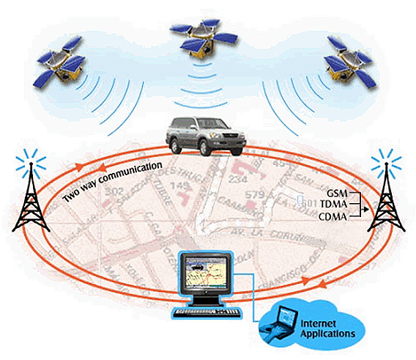

**Know where your vehicle is**

A basis for remote vehicle monitoring is a small hardware device mounted inside the car, truck or ships. The device is actually an on-board microcontroller with GPS and wireless communication capabilities that transfers all relevant information from vehicle to the fleet management center. It gives you straight answers to the questions like: where did the vehicle drive for the last, say, 10 days, where did it stop, how fast did it drive, was there over speeding moments, how many kilometers did it make, and much more.!

**Real Time Monitoring**

Real-time monitoring of vehicles as they move from place to place, halt for re-fueling and other stops is among the biggest advantages of vehicle tracking system Speed checks of vehicles, accurate location, refreshment breaks and other stops by drivers can be tracked as they occur. So once the tracking system is installed in your vehicle you get live update of the movement of your vehicle on your computer connected to internet and also on your mobile through SMS.

**Tracking Advantages:**

Reduction of

* Working hours
* Idle time cost
* Fuel costs
* Vehicle thefts
* Insurance expenses
* Communication with the driver expenses

**Increase of:**

* Delivery speed
* Level of organization
* Transport reliability
* Accuracy
* Work discipline
* Business productivity

**How does it work?**

A GPS receiver uses microwaves received from 4 GPS satellites to pinpoint its position (in terms of latitude and longitude) on the surface of the earth with a minimal error of 2-5 meters. And, this is all possible in real-time, the GPS receiver being capable of generating 5 geographical coordinates per second. A tiny CPU processes the data, and transfers it as per requirement to a wireless GSM/GPRS module which directly uploads data to our vehicle tracking server. Once there, you can see all tracking information on the internet.